Connecting to managed AWS services

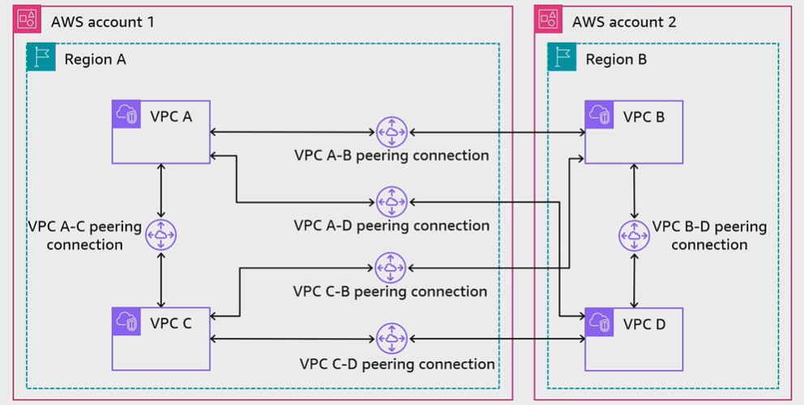
A. Mesh architecture using VPC peering

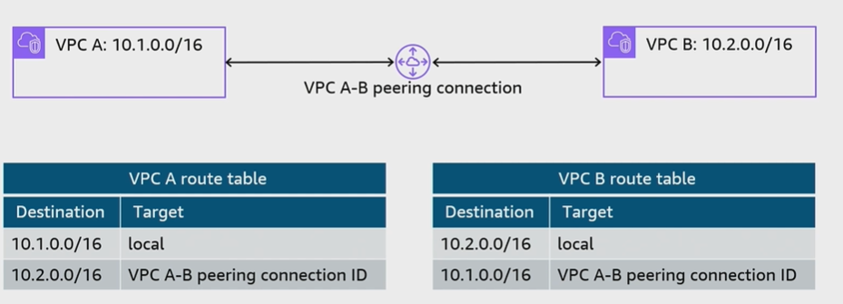
B. Establishing VPC peering

C. VPC peering does not support transitive peering
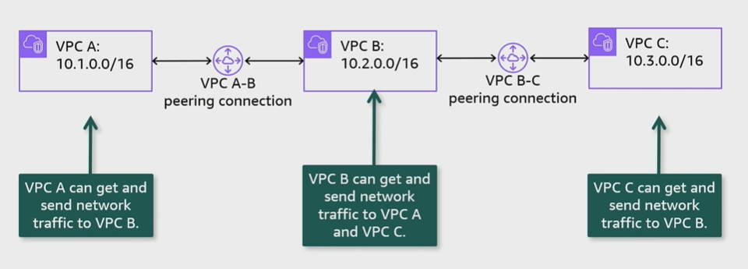

D. Use cases: Peering to one VPC to access centralized resources
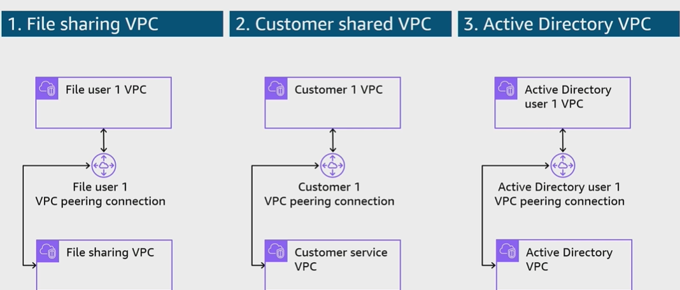

E. VPC connectivity with AWS PrivateLink architecture
